Synopsis

Disease Risk Prediction using Machine Learning Classification System

Problem Id:
1
Student Name :
- Samarth Tomer
2028834
- Sparsh Saxena
2028864

- Tanmay Kumar
2028879

Section : Q G2

- Problem Description:
The project aims to design and develop an end-to-end machine learning classification system to predict disease risk using patient clinical data. In today’s world, early detection of diseases plays a crucial role in improving healthcare outcomes and reducing medical costs. Manual diagnosis can sometimes be time-consuming and prone to human error. Therefore, this system uses machine learning algorithms to assist in predicting whether a patient is at risk of a disease based on input features such as age, medical history, and other clinical parameters.
The project involves data preprocessing techniques such as cleaning, normalization, and transformation to ensure data quality. Important features are selected to improve model performance and interpretability. Multiple classification algorithms like Logistic Regression, K-Nearest Neighbors (KNN), and Support Vector Machine (SVM) are used and compared. The system is evaluated using standard metrics like accuracy, precision, recall, and F1-score. This project demonstrates a complete ML pipeline and its real-life application in healthcare.
- Steps of Implementation:
1)Data Collection – Using Python, NumPy, and Pandas, we collect or generate data that represents user behavior on an e-commerce website. The dataset includes features such as browsing time, number of clicks, product views, session duration, bounce rate, and exit rate, along with categorical data like user type and product category.

2)Data Preprocessing - This step involves cleaning and preparing the dataset before applying machine learning algorithms. It includes handling missing values, and scal encoding categorical data, and scaling features to improve model.

3)Feature Selection – Feature selection is the process of selecting the most important features
that contribute to prediction. It removes irrelevant data, reduces, exity, and improves model accuracy.

4)Model Training – We will split the dataset into training and testing sets to evaluate model performance. Using selected features, we train machine learning models such as Logistic Regression and K-Nearest Neighbors(KNN). This model learn patterns from the training data to make predictions.

5)Model Evaluation – Model evaluation is used to measure how well the model performs on unseen data. Metrics like accuracy, precision, recall, and F1 score help in comparing and selecting the best model.

6)Visualization – Plot confusion matrix and ROC curve.

7)Prediction – Final model predicts disease risk.

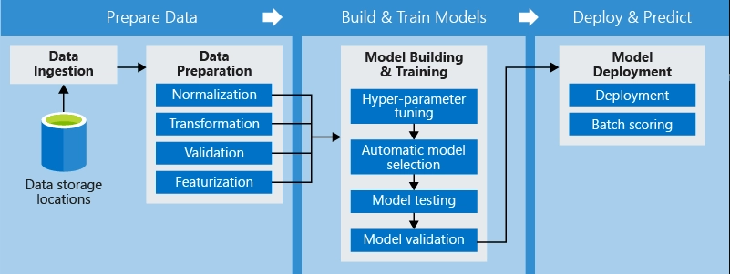

- Expected Modules/ Libraries to be used :
1)NumPy – Used for numerical operations and array handling.
2)Pandas – Used for data manipulation and analysis.
3)Matplotlib – Used for plotting graphs and visualizations.
4)Seaborn – Used for advanced data visualization.
5)Scikit-learn – Used for machine learning algorithms and evaluation metrics.

- Expected Evaluation metrics and Plots to be used:
Accuracy – Measures overall correctness of the model.
Precision – Measures correctness of positive predictions.
Recall – Measures ability to find all positive cases.
F1-score – Harmonic mean of precision and recall.
Confusion Matrix – Shows correct and incorrect predictions.
ROC Curve – Shows performance of classification model at different thresholds.

- Required topics from the subject:
Strings – Used for handling dataset column names and categorical data.
Pointers – Useful in understanding memory handling in preprocessing (conceptual use).
Files – Used to read dataset files (CSV) and store outputs.
- Platform Required:
Jupyter Notebook / Python (Anaconda / VS Code)

- Books and Link Sources:
Hands-On Machine Learning with Scikit-Learn – Aurélien Géron
Introduction to Machine Learning – Ethem Alpaydin
https://www.kaggle.com
https://scikit-learn.org

